**HOTEL BOOKING ANALYSIS**

In recent years, City Hotels and resorts have seen the highest cancellations rates. Each hotel is now dealing with a number of issues as a result, including fewer of revenue and less than ideal hotel room use. Consequently, lowering cancellation rates is both hotels’ primary goal to increase their efficiency in generating revenue, and for us to offer thorough business advice to address this problem.

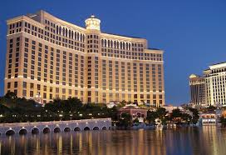

**Assumption:**

* No unusual occurrence between 2015 and 2017 will have a substantial impact on the data used.
* The information ins still current can be used to analyze a hotel’s possible plan in effective manner.
* The hotels are not currently using any suggested solution.
* The biggest factor affecting the effectiveness of the earning income is cancellation.

**Analysis and Finding**

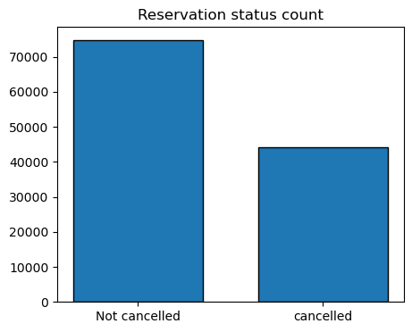

The accompanying bad graph shows the percentage of reservations that are cancelled and those are not. It looks like there is significant amount of reservation that are not cancelled. Around 37% of clients cancelled their booking, which make markable impact on company’s revenue as well as profit.

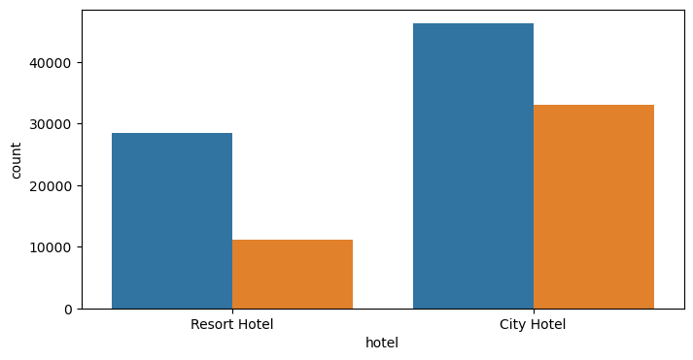

In comparison to resort hotels, city hotels have more bookings. It’s possible that resort hotels are more expensive than those in cities.

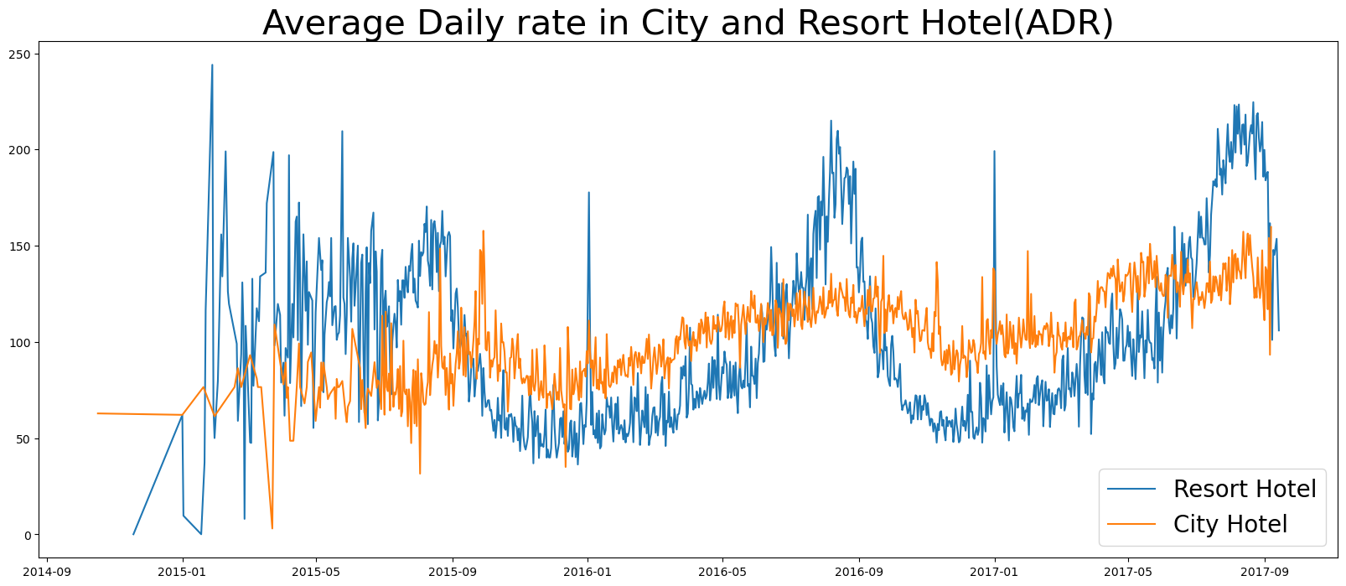

The line graphs above show that, on certain days, the average daily rate for city hotel is less than that of a resort hotel. And on other days, it’s even less. It goes without saying weekends and holidays may see a rise in resort hotels rate.

We have developed grouped bar graphs to analyze the months with the highest and lowest reservation levels according to reservation status. As can be seen, both the number of confirmed reservation and the number of canceled reservations are largest in the month of august. Whereas January is the month with most canceled reservations.

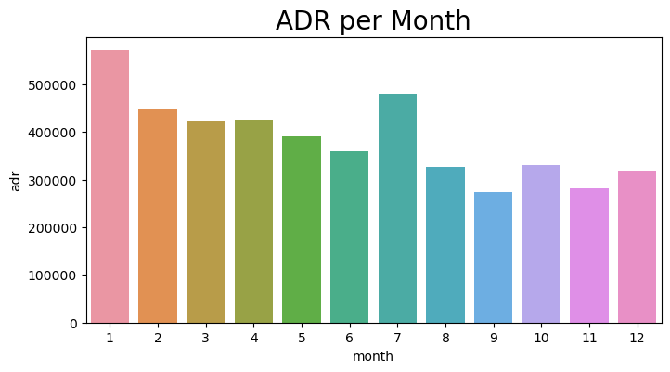

The graph indicates that cancellations are most common when prices are more and are least commo where it is low. Therefore cost of accommodation is solely responsible for cancellation.

Now, let’s see which country has he highest reservation cancelled. The top county is Portugal with the highest number of cancellation.

Let’s check the area from where guests are visiting the hotels and making reservation.is it coming from direct or groups, Online or offline? Around 46% of the clients come from online travel agencies, whereas 27% come from groups. Only 4% of clients book hotel directly by vising them and making reservations.

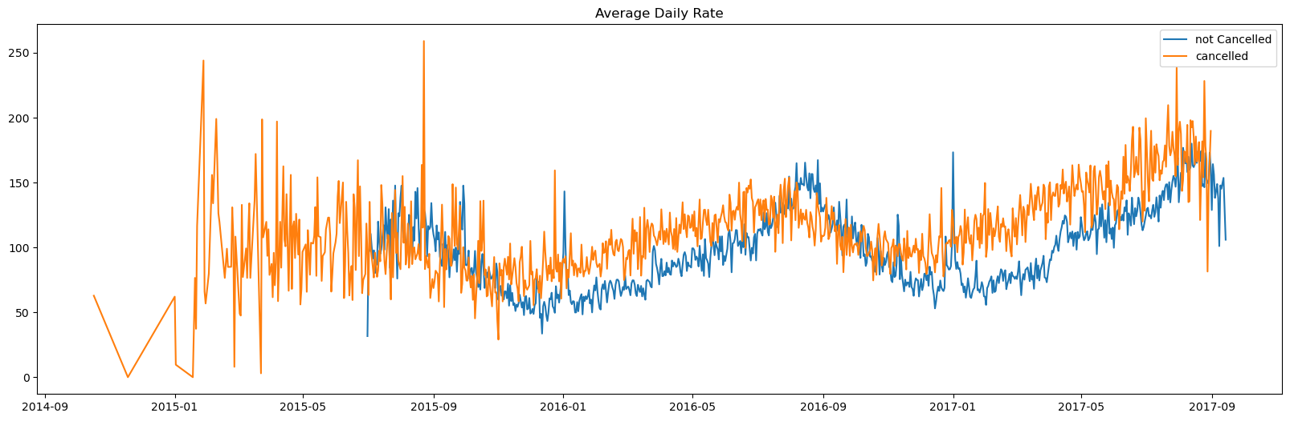

As seen in the graphs, reservations are cancelled when the average daily rate is higher then when it is not cancelled. It is clearly proves all the above analysis, that the higher price leads to higher cancellation.

**Suggestions:**

1. Cancellation rates rise as the price does. In order to prevent cancellation of reservation hotel could work on their pricing strategies and try to lower the rates of specific hotels based on location.
2. As the ration of cancelation and not cancellation of resort hotel us higher in the resort hotel then the city hotel. So the hotels should provide a reasonable discount on the room prices on weekend or on Holidays.
3. Hotel can start campaigns on the start of every year as January is the month of highest cancellation.
4. They can also increase the quality of their hotels and their services mainly in Portugal to reduce the cancellation rate.